MIT Academy of Engineering
EDS_Theory_Assignment_2
Name: Amod Muley
PRN: 202501090003
Batch: ME1(M11)

📊 Dataset Description:
The COVID-19 dataset contains detailed information about the spread of coronavirus across different countries and dates. It includes attributes such as total confirmed cases, new cases, total deaths, new deaths, recoveries, and active cases. This dataset helps in analyzing the growth pattern, severity, and recovery trends of the pandemic over time.

❓ Problem Statement:
During the COVID-19 pandemic, it is important to identify regions where the situation is worsening rapidly. This analysis aims to detect such critical regions by studying the increase in daily cases.
Using NumPy, we calculate the variation between total confirmed cases and previous day cases to determine daily growth. Then, with the help of Pandas, we identify regions where the growth rate is significantly higher than the average trend. The final output highlights countries with alarming increases in cases for better monitoring and decision-making.

💻 Code:

import pandas as pd
import numpy as np

# Step 1: Read dataset
data = pd.read_csv("covid_data.csv")

# Step 2: Convert columns into NumPy arrays
total_cases = data['TotalCases'].to_numpy()
new_cases = data['NewCases'].to_numpy()

# Step 3: Compute growth ratio (avoid division by zero)
growth_rate = new_cases / (total_cases + 1)

# Step 4: Add new column
data['GrowthRate'] = growth_rate

# Step 5: Statistical analysis using NumPy
avg_growth = np.mean(growth_rate)
std_growth = np.std(growth_rate)

# Step 6: Define cutoff for high-risk regions
cutoff_value = avg_growth + std_growth

# Step 7: Filter countries using Pandas
high_risk = data[data['GrowthRate'] > cutoff_value][
['Country', 'Date', 'TotalCases', 'NewCases', 'GrowthRate']
]

# Step 8: Print results
print(f"Average Growth Rate: {avg_growth:.4f}")
print(f"Standard Deviation: {std_growth:.4f}")
print(f"Cutoff Value: {cutoff_value:.4f}")
print("-" * 35)

print(f"Total High Risk Entries: {high_risk.shape[0]}")
print("\nSample Data:")
print(high_risk.head(10))

📈 Output:
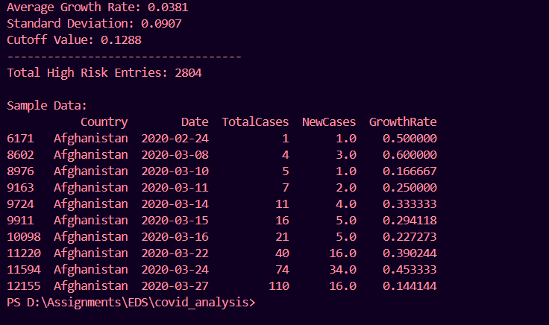
✅ Conclusion:
This study uses NumPy and Pandas to analyze the spread of COVID-19 by measuring the daily growth rate of cases. The results help in identifying regions where the number of cases is increasing rapidly. This information can assist governments and health organizations in taking timely actions, allocating resources, and controlling the spread of the virus effectively.

📸 Code Screenshot:
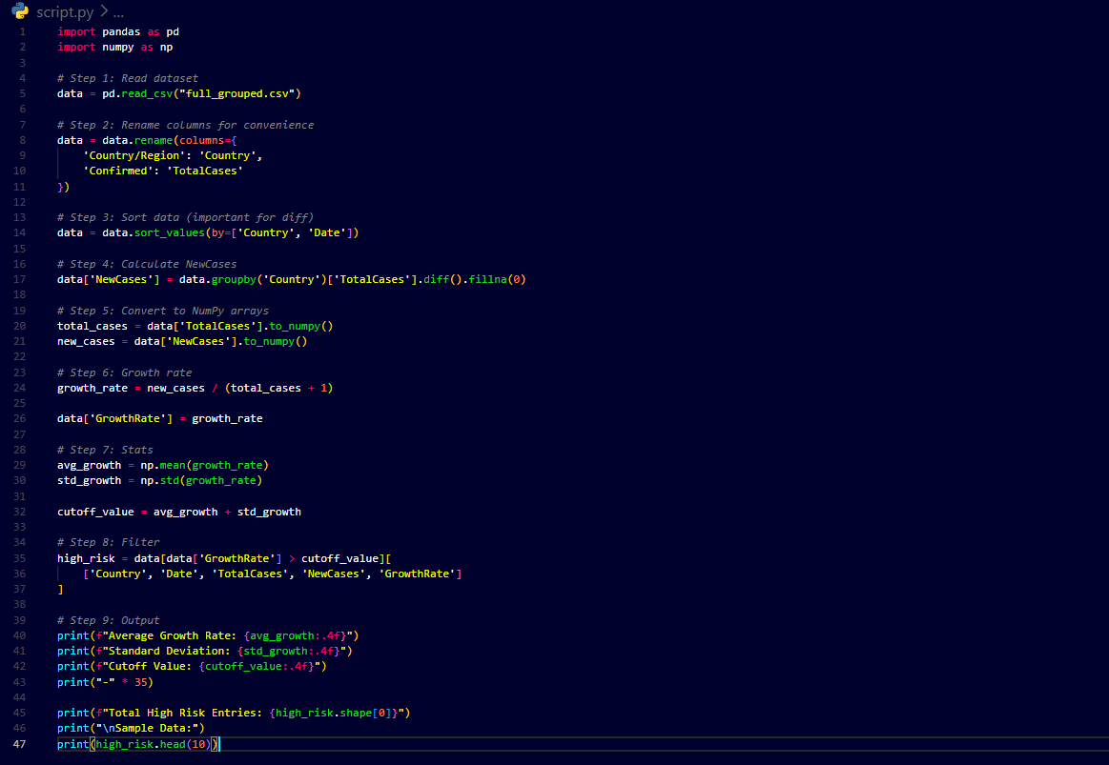
🔗 Dataset Link:
https://www.kaggle.com/datasets/imdevskp/corona-virus-report

